**PROJECT PROPOSAL**

**PROBLEM STATEMENT/CHALLENGE**

The challenge is to build a technology enabled system to monitor quality parameters of the water and sludge discharged by the Sewage Treatment Plants (STPs) and Industrial Effluent Treatment Plants (ETPs) across the city.

**PROPOSED SOLUTION**

The inefficiency today in the monitoring of water and sewage is because of lack of data about quantity, quality and usage. If these three parameters are met, the process of management becomes all the more simpler.

Our project hence proposes a solution to meet the three parameters and then use the data efficiently to tackle this problem.

Our solution is simple:  
The Raspberry Pi forms the integral part of our system. It handles all the sensor values, sends it to the cloud platform via internet and the data is displayed on the web interface or the app. Based on if the water is contaminated the application device performs purification or sends a call back for action whichever is feasible.

Based on the data received, the system then decides the type of action required by mapping it to the local database which stores threshold levels of each of the sensors. If the sensor value is higher than the normal threshold, then action is taken. Its a simple autonomous feedback system.

**The block diagram is as follows:**

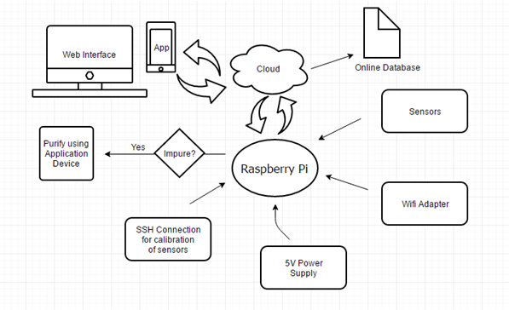

**Why Raspberry Pi 3?**

Considering minimal power consumption, higher processing power and space constraints, the Raspberry Pi 3 stands out as the most optimal choice.

Being the size of a credit card, it has higher processing power and consumes very little power. It has 40 GPIO pins which can be used for interfacing the sensors. For sensors requiring USB interface the four USB Ports can be used for their disposal.

It can be powered by a 5V micro USB charger. It can also be connected to the internet with the use of a wireless internet USB adapter.

Broadcom BCM 2835 processor inbuilt chip provides faster processing capabilities. Based on Linux based operating system, the open source nature of this OS allows for innovation and experimentation.

**The project involves the use of Raspberry Pi to act as the main system which will handle the following tasks:**

1) Handle or manipulate different data received from numerous sensors.

2) Store the values of the sensors over a predefined time period.

3) Control the functioning of different sensors as and when required.

4) Send data to a remote server/cloud continuously whenever a state change is detected.

5) Send location details for organized monitoring of data across places.

**UNIQUENESS**

On thorough research, it was found that sensor kits which sense many of the required parameters like BoD, CoD, pH, TSS etc are already available. These kits also include in-built GPS/GPRS systems which can be used to transfer stored data. But, the drawback with these kits is that they are very expensive and cost from 10 to 15 lakhs per kit.

How our implementation is different from these kits:-  
1) Interfacing different sensors for different parameters, which are averagely priced.  
2) Interfacing to one single Raspberry Pi Board which has very high processing speed and input/output capabilities.  
3) Simple transfer of data from the Pi to the stations with a low cost Wifi adapter and cloud storage, thereby eliminating the use of high cost GPS modules.

**PRE WORK**

A project titled “Water Monitoring and Conditioning System” was done. This system uses the AVR ATmega32 microcontroller with several sensors to monitor the state of water and includes the necessary components to control the same. The outputs of the sensors were calibrated and the real time status was displayed on an LCD. Almost all the critical properties of water can be taken care of by this system. Any change from the desired properties were be diminished and the desired environment could be maintained.

Water monitoring systems can be used in any domain where it is necessary to continuously monitor and ensure certain standards for water. Such systems would find many applications in large water bodies where gathering data can be automated and stored for future use. The same idea can be used in this particular project.

* **Problem Definition**

To design an electrical system which can monitor the state of water in a tank or water body via appropriate sensors and control it with the help of additional peripherals, each programmed to control the water such that there is no significant deviation from the desired state.

* **Proposed Solution**

The Atmel ATmega32 microcontroller is used to carry out all the monitoring and controlling processes. A waterproof temperature sensor (DS18B20) is used to read the temperature and a water heater is connected to maintain the optimum temperature if the temperature goes below the desired value. There is a water level detecting circuit which when the level falls below the required limit, activates the pump which then refills the water. There is also a filter which filters out the dirt and silt and maintains the purity level. An LCD display has been integrated as an interface to display messages when critical levels have been reached and also temperature and pump status. All the interfacing is done with the help of relays(electro-mechanical switches) for on-off control.

* **Objectives**

1. To come up with a solution to monitor and control the state of water in a way that doesn’t require a lot of external attention and interference.
2. To design a system which can monitor the water in a water body continuously, thus eliminating the need for impractical manual labour.

**Usage of the above idea in this project**

The above project just senses minimal parameters. The same idea can be extended towards this project. Multiple sensors which measure the parameters like BOD, COD, TSS, pH etc can be interfaced with a suitable microcontroller as shown above, and the data obtained from the sensors can be calibrated appropriately. This data can then be transferred to the base stations through suitable communication protocols, for later analysis.

**Research**

The problem of environmental pollution due to toxic metals has begun a big concern now in most of the major metropolis. Many of the rivers, lakes and oceans have been contaminated by pollutants. Some of these pollutants are directly discharged by industrial plants. The Vrishabhavathi river once used as a major drinking water source to the populace living across the river. It receives treated and untreated effluents from treatment plants of Bangalore water supply and sewerage board, containing various organic contaminants, toxic heavy metals etc.

The main watershed of Bangalore, Vrishabhavathi watershed carries polluted effluents from two major industrial areas, Peenya and Rajajinagar, domestic sewage effluents of both treated and untreated water, directly discharged into it from a large part of city. It also carries Industrial along Bangalore-Mysore state highway factories and Bidadi Industrial area. The experimental data of physicochemical parameters of water samples collected at different sites across Vrishabhavathi river water is presented in table 1.

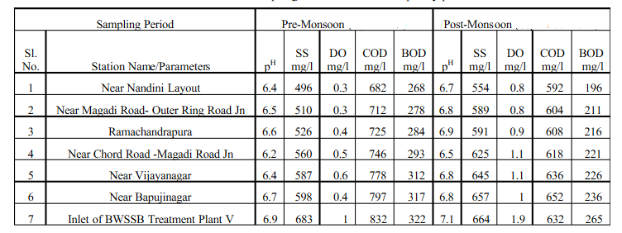

**IMPLEMENTATION STEPS**

1. Detection and calibrating of the desired water parameters like pH, BOD, COD, NH4-N, N-Total, TSS.

Different sensors which sense the above parameters will be interfaced with a **Raspberry Pi 3 Board**, and the sensor outputs will be calibrated appropriately. The final parameter values are stored in the memory of the microprocessor, for later use.

1. Transferring sensor data to cloud

The data from the sensors is stored in the Raspberry Pi. This data is uploaded to **ThingSpeak Cloud platform** using a wifi adapter for the Raspberry Pi. All the data is real-time, and spontaneous.

1. Transfer of cloud data to the required stations.

**SENSORS**

**1) pH meter**

A pH Meter is a [scientific instrument](https://en.wikipedia.org/wiki/Scientific_instrument) that measures the hydrogen-ion concentration (or [pH](https://en.wikipedia.org/wiki/PH)) in a solution, indicating its [acidity](https://en.wikipedia.org/wiki/Acidity) or [alkalinity](https://en.wikipedia.org/wiki/Alkalinity). To measure the pH of the sewage water can be done using digital pH meter which cost around Rs4000. Dimension(cm) of it is 25.4 x 15.24 x 8.89 and Operating Ranges from pH : 0.00 to 14.00. It operates on a supply of 220v.

**2) Ammonium sensor**

The ammonium sensor is used to measure the level of ammonium ions in the water. This measurement can be done using ion selective electrodes. Dimensions of the sensor are: Length - 15.5 cm Diameter - 1.2 cm Operating Range - 1 mg/l to 1800 mg/1

**3) Total nitrogen measurement**

Raw sewage contains quite high concentrations of urea and amines and proteinaceous compounds which break into ammonia on standing. TN-2A Total Nitrogen analyzer ammonia gauge can be used in measuring total nitrogen. Measuring range: 0.05 ~ 100mg /L and can be easily interfaced to the Raspberry Pi USB port.

**4) TSS sensor**

Suspended solids can lead to the development of sludge deposits and anaerobic conditions when untreated wastewater is discharged to the aquatic environment. If the suspended solids concentration exceeds the required limits, intervention is required to rectify the situation. a TSS analyser can be used to monitor this parameter.

**5) Faecal Coliforms**

Faecal coliform bacteria are found in water wherever the water is contaminated with faecal waste of human or animal origin. Faecal coliforms are primarily used to indicate the presence of bacterial pathogens such as Salmonella spp., Shigella spp.,

**6) Chemical Oxygen Demand**

Biodegradable organics are principally composed of proteins, carbohydrates and fats, and are commonly measured in terms of Chemical Oxygen Demand (COD). If discharged untreated to the environment, their biological stabilisation can lead to depleted oxygen levels and the development of septic conditions. If the COD exceeds the required limits, intervention is required to rectify the situation. To analyse COD data COD analyzer with measurement range: COD: 5 ~ 2000mg / L, exceeding the dilution determined can sense the COD accurately. It cost around Rs 42,000

7)**Biochemical oxygen demand**

Biochemical oxygen demand is the amount of [dissolved oxygen](https://en.wikipedia.org/wiki/Oxygenation_%28environmental%29) needed by aerobic biological organisms to break down organic material present in a given water sample at certain temperature over a specific time period. BOD analyzer can be used to analyse and BOD. Measuring Range: 0mg/L~1000mg/L and Measuring Method: Differential pressure method. this cost around Rs 60,000.

**AREAS OF IMPLEMENTATION**

The entire system after completion can be installed in many places where sewage treatment plants are available. We plan to test our device in the following locations:-

1) BWSSB Wastewater Treatment Plant, RR Nagar, Bangalore.  
2) Near Magadi Road-Outer Ring Road Junction.   
3) Near Chord Road-Magadi Road Junction.   
4) Near Vijaynagar.   
5) Near Nandini Layout.

The first phase of the project can be tested using samples of wastewater. A tank filled with waste water will be used to test and demonstrate the working of the device.  
  
In the water treatment plants and other areas the main channel of treated water will be diverted into a small alternate channel, where the device is dipped, for data acquisition and storage.

**BUDGET PLAN**

For the prototype, we plan to implement the interface using the discrete sensors mentioned above, to analyse parameters mentioned below

1. pH details
2. BOD analysis
3. COD analysis
4. TSS analysis
5. NH4-N
6. N total
7. Faecal coliform
8. Battery resources
9. IOT setup

From the survey done by us, the budget for the prototype implementation will be approximately

**5 lakhs**, which will be done in multiple stages.

For the complete online monitoring setup, cost of implementation will be around **15 lakhs**(3 devices to be setup in 3 different locations in Bangalore).

**Approximate cost of sensors**

Digital pH Meter - Rs. 4000  
TSS Sensor - Rs. 75000  
NH4-N Sensor - Rs. 30000  
N-Total Sensor - Rs. 33000  
DO Sensor - Rs. 42000   
COD analyser - Rs. 42,000   
BOD analyser - Rs. 60,000

**HUMAN RESOURCE**

The human resources involved in the development of the prototype includes the team of four student applicants who wish to undertake the project under the guidance of their faculty mentor. The team aims to collaborate with a startup company that is interested in assisting the students in the process, in the later stages of advertising and marketing.

**BUSINESS PLAN**

1. Partnership with a startup to promote the product in the market.
2. Approach other state governments in India where there are sewage treatment problems.
3. Approach many of the famous wastewater treatment plants and install the product there.